
3G TS 25.213 V3.4.0 (2000-12)
Technical Specification
3rd Generation Partnership Project;
Technical Specification Group Radio Access Network;
Spreading and modulation (FDD)
(Release 1999)

The present document has been developed within the 3rd Generation Partnership Project (3GPP TM) and may be further elaborated for the purposes of 3GPP.
The present document has not been subject to any approval process by the 3GPP Organisational Partners and shall not be implemented.
This Specification is provided for future development work within 3GPP only. The Organisational Partners accept no liability for any use of this Specification.
Specifications and reports for implementation of the 3GPP TM system should be obtained via the 3GPP Organisational Partners' Publications Offices.

Keywords

3GPP
Postal address

3GPP support office address
650 Route des Lucioles - Sophia Antipolis
Valbonne - FRANCE
Tel.: +33 4 92 94 42 00 Fax: +33 4 93 65 47 16
Internet
http://www.3gpp.org
Copyright Notification
No part may be reproduced except as authorized by written permission.
The copyright and the foregoing restriction extend to reproduction in all media.

© 2000, 3GPP Organizational Partners (ARIB, CWTS, ETSI, T1, TTA,TTC).
All rights reserved.
Contents
Foreword 5
1 Scope 6
2 References 6
3 Symbols and abbreviations 6
3.1 Symbols 6
3.2 Abbreviations 6
4 Uplink spreading and modulation 7
4.1 Overview 7
4.2 Spreading 7
4.2.1 DPCCH/DPDCH 7
4.2.2 PRACH 9
4.2.2.1 PRACH preamble part 9
4.2.2.2 PRACH message part 9
4.2.3 PCPCH 9
4.2.3.1 PCPCH preamble part 9
4.2.3.2 PCPCH message part 9
4.3 Code generation and allocation 10
4.3.1 Channelization codes 10
4.3.1.1 Code definition 10
4.3.1.2 Code allocation for DPCCH/DPDCH 11
4.3.1.3 Code allocation for PRACH message part 11
4.3.1.4 Code allocation for PCPCH message part 11
4.3.1.5 Channelisation code for PCPCH power control preamble 12
4.3.2 Scrambling codes 12
4.3.2.1 General 12
4.3.2.2 Long scrambling sequence 12
4.3.2.3 Short scrambling sequence 13
4.3.2.4 DPCCH/DPDCH scrambling code 14
4.3.2.5 PRACH message part scrambling code 15
4.3.2.6 PCPCH message part scrambling code 15
4.3.2.7 PCPCH power control preamble scrambling code 15
4.3.3 PRACH preamble codes 15
4.3.3.1 Preamble code construction 15
4.3.3.2 Preamble scrambling code 16
4.3.3.3 Preamble signature 16
4.3.4 PCPCH preamble codes 16
4.3.4.1 Access preamble 16
4.3.4.1.1 Access preamble code construction 16
4.3.4.1.2 Access preamble scrambling code 17
4.3.4.1.3 Access preamble signature 17
4.3.4.2 CD preamble 17
4.3.4.2.1 CD preamble code construction 17
4.3.4.2.2 CD preamble scrambling code 17
4.3.4.2.3 CD preamble signature 18
4.4 Modulation 18
4.4.1 Modulating chip rate 18
4.4.2 Modulation 18
5 Downlink spreading and modulation 18
5.1 Spreading 18
5.2 Code generation and allocation 19
5.2.1 Channelization codes 19
5.2.2 Scrambling code 20
5.2.3 Synchronisation codes 21
5.2.3.1 Code generation 21
5.2.3.2 Code allocation of SSC 22
5.3 Modulation 24
5.3.1 Modulating chip rate 24
5.3.2 Modulation 24
Annex A (informative): Generalised Hierarchical Golay Sequences 25
A.1 Alternative generation 25
Annex B (informative): Change history 26

Foreword
This Technical Specification (TS) has been produced by the 3rd Generation Partnership Project (3GPP).
The contents of the present document are subject to continuing work within the TSG and may change following formal TSG approval. Should the TSG modify the contents of the present document, it will be re-released by the TSG with an identifying change of release date and an increase in version number as follows:
Version x.y.z
where:
x the first digit:
1 presented to TSG for information;
2 presented to TSG for approval;
3 or greater indicates TSG approved document under change control.
y the second digit is incremented for all changes of substance, i.e. technical enhancements, corrections, updates, etc.
z the third digit is incremented when editorial only changes have been incorporated in the document.

1 Scope
The present document describes spreading and modulation for UTRA Physical Layer FDD mode.

2 References
The following documents contain provisions which, through reference in this text, constitute provisions of the present document.
- References are either specific (identified by date of publication, edition number, version number, etc.) or non-specific.
- For a specific reference, subsequent revisions do not apply.
- For a non-specific reference, the latest version applies.
[1] 3G TS 25.201: "Physical layer - general description".
[2] 3G TS 25.211: "Physical channels and mapping of transport channels onto physical channels (FDD)."
[3] 3G TS 25.101: "UE Radio transmission and Reception (FDD)".
[4] 3G TS 25.104: "UTRA (BS) FDD; Radio transmission and Reception".

3 Symbols and abbreviations

3.1 Symbols
For the purposes of the present document, the following symbols apply:
C_{ch,SF,n}: n:th channelisation code with spreading factor SF
C_{pre,n,s}: PRACH preamble code for n:th preamble scrambling code and signature s
C_{c-acc,n,s}: PCPCH access preamble code for n:th preamble scrambling code and signature s
C_{c-cd,n,s}: PCPCH CD preamble code for n:th preamble scrambling code and signature s
C_{sig,s}: PRACH/PCPCH signature code for signature s
S_{dpch,n}: n:th DPCCH/DPDCH uplink scrambling code
S_{r-pre,n}: n:th PRACH preamble scrambling code
S_{r-msg,n}: n:th PRACH message scrambling code
S_{c-acc}: n:th PCPCH access preamble scrambling code
S_{c-cd}: n:th PCPCH CD preamble scrambling code
S_{c-msg,n}: n:th PCPCH message scrambling code
S_{dl,n}: DL scrambling code
C_{psc}: PSC code
C_{ssc,n}: n:th SSC code

3.2 Abbreviations
For the purposes of the present document, the following abbreviations apply:
AICH Acquisition Indicator Channel
AP Access Preamble
BCH Broadcast Control Channel
CCPCH Common Control Physical Channel
CD Collision Detection
CPCH Common Packet Channel
CPICH Common Pilot Channel
DCH Dedicated Channel
DPCH Dedicated Physical Channel
DPCCH Dedicated Physical Control Channel
DPDCH Dedicated Physical Data Channel
FDD Frequency Division Duplex
Mcps Mega Chip Per Second
OVSF Orthogonal Variable Spreading Factor (codes)
PDSCH Physical Dedicated Shared Channel
PICH Page Indication Channel
PRACH Physical Random Access Channel
PSC Primary Synchronisation Code
RACH Random Access Channel
SCH Synchronisation Channel
SSC Secondary Synchronisation Code
SF Spreading Factor
UE User Equipment

4 Uplink spreading and modulation

4.1 Overview
Spreading is applied to the physical channels. It consists of two operations. The first is the channelization operation, which transforms every data symbol into a number of chips, thus increasing the bandwidth of the signal. The number of chips per data symbol is called the Spreading Factor (SF). The second operation is the scrambling operation, where a scrambling code is applied to the spread signal.
With the channelization, data symbols on so-called I- and Q-branches are independently multiplied with an OVSF code. With the scrambling operation, the resultant signals on the I- and Q-branches are further multiplied by complex-valued scrambling code, where I and Q denote real and imaginary parts, respectively.

4.2 Spreading

4.2.1 DPCCH/DPDCH
Figure 1 illustrates the principle of the uplink spreading of DPCCH and DPDCHs. The binary DPCCH and DPDCHs to be spread are represented by real-valued sequences, i.e. the binary value "0" is mapped to the real value +1, while the binary value "1" is mapped to the real value –1. The DPCCH is spread to the chip rate by the channelization code c_{c}, while the n:th DPDCH called DPDCH_{n} is spread to the chip rate by the channelization code c_{d,n}. One DPCCH and up to six parallel DPDCHs can be transmitted simultaneously, i.e. 1 ≤ n ≤ 6.
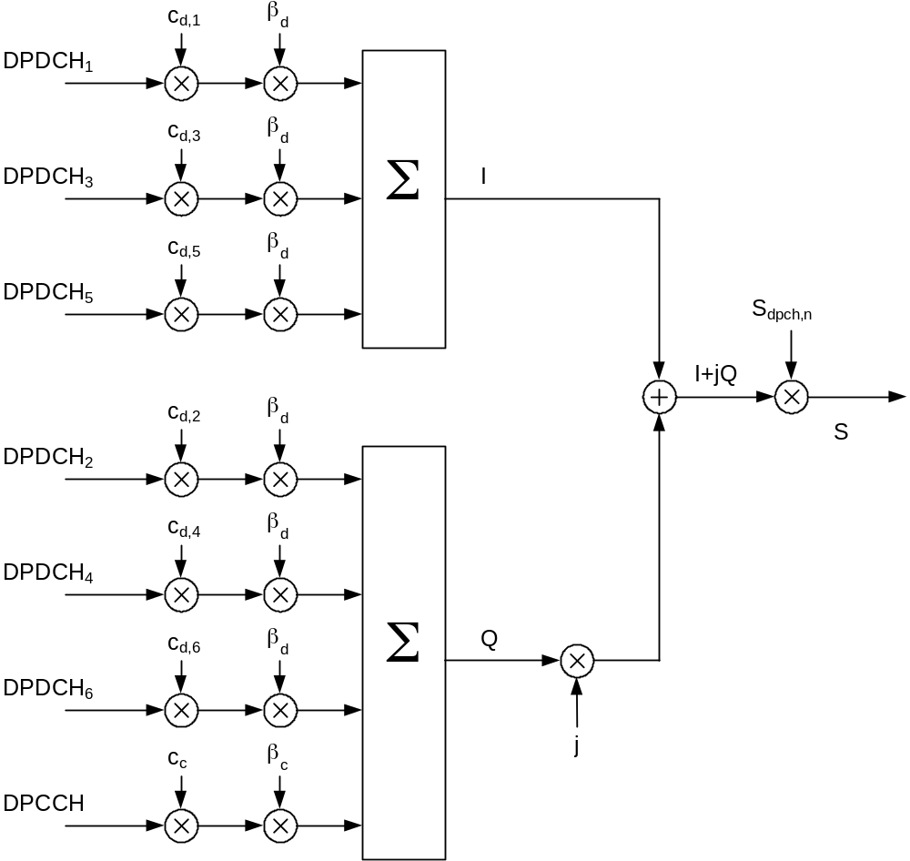
Figure 1: Spreading for uplink DPCCH and DPDCHs
After channelization, the real-valued spread signals are weighted by gain factors, β_{c} for DPCCH and β_{d} for all DPDCHs.
At every instant in time, at least one of the values β_{c} and β_{d} has the amplitude 1.0. The β-values are quantized into 4 bit words. The quantization steps are given in table 1.
Table 1: The quantization of the gain parameters
Signalling values for  β_{c} and β_{d} | Quantized amplitude ratios  β_{c} and β_{d}
15 | 1.0
14 | 14/15
13 | 13/15
12 | 12/15
11 | 11/15
10 | 10/15
9 | 9/15
8 | 8/15
7 | 7/15
6 | 6/15
5 | 5/15
4 | 4/15
3 | 3/15
2 | 2/15
1 | 1/15
0 | Switch off

After the weighting, the stream of real-valued chips on the I- and Q-branches are then summed and treated as a complex-valued stream of chips. This complex-valued signal is then scrambled by the complex-valued scrambling code S_{dpch,n}. The scrambling code is applied aligned with the radio frames, i.e. the first scrambling chip corresponds to the beginning of a radio frame.

4.2.2 PRACH

4.2.2.1 PRACH preamble part
The PRACH preamble part consists of a complex-valued code, described in section 4.3.3.

4.2.2.2 PRACH message part
Figure 2 illustrates the principle of the spreading and scrambling of the PRACH message part, consisting of data and control parts. The binary control and data parts to be spread are represented by real-valued sequences, i.e. the binary value "0" is mapped to the real value +1, while the binary value "1" is mapped to the real value –1. The control part is spread to the chip rate by the channelization code c_{c}, while the data part is spread to the chip rate by the channelization code c_{d}.
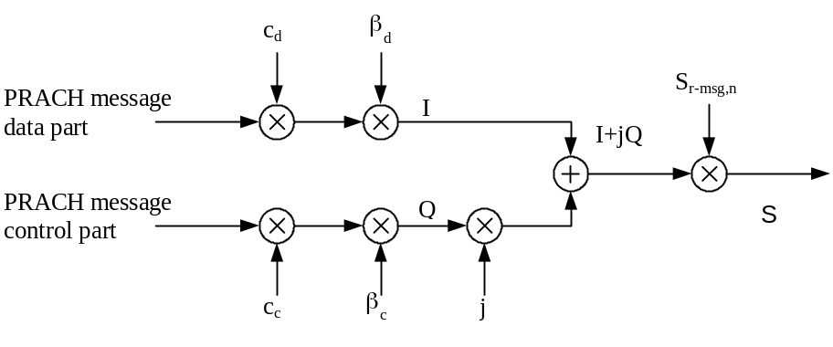
Figure 2: Spreading of PRACH message part
After channelization, the real-valued spread signals are weighted by gain factors, β_{c} for the control part and β_{d} for the data part. At every instant in time, at least one of the values β_{c} and β_{d} has the amplitude 1.0. The β-values are quantized into 4 bit words. The quantization steps are given in section 4.2.1.
After the weighting, the stream of real-valued chips on the I- and Q-branches are treated as a complex-valued stream of chips. This complex-valued signal is then scrambled by the complex-valued scrambling code S_{r-msg,n}. The 10 ms scrambling code is applied aligned with the 10 ms message part radio frames, i.e. the first scrambling chip corresponds to the beginning of a message part radio frame.

4.2.3 PCPCH

4.2.3.1 PCPCH preamble part
The PCPCH preamble part consists of a complex-valued code, described in section 4.3.4.

4.2.3.2 PCPCH message part
Figure 3 illustrates the principle of the spreading of the PCPCH message part, consisting of data and control parts. The binary control and data parts to be spread are represented by real-valued sequences, i.e. the binary value "0" is mapped to the real value +1, while the binary value "1" is mapped to the real value –1. The control part is spread to the chip rate by the channelization code c_{c}, while the data part is spread to the chip rate by the channelization code c_{d}.
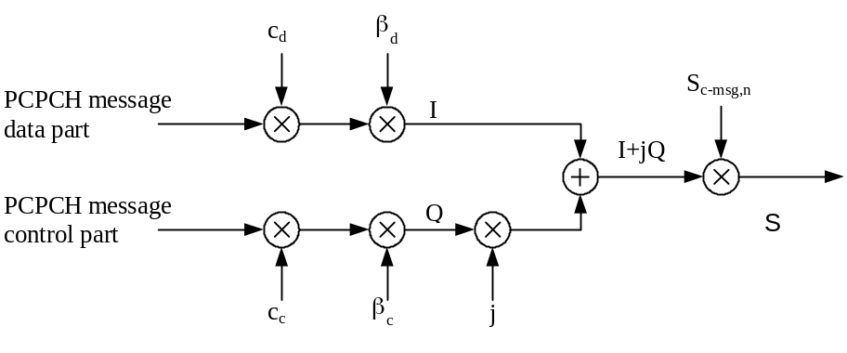
Figure 3: Spreading of PCPCH message part
After channelization, the real-valued spread signals are weighted by gain factors, β_{c} for the control part and β_{d} for the data part. At every instant in time, at least one of the values β_{c} and β_{d} has the amplitude 1.0. The β-values are quantized into 4 bit words. The quantization steps are given in section 4.2.1.
After the weighting, the stream of real-valued chips on the I- and Q-branches are treated as a complex-valued stream of chips. This complex-valued signal is then scrambled by the complex-valued scrambling code S_{c-msg,n}. The 10 ms scrambling code is applied aligned with the 10 ms message part radio frames, i.e. the first scrambling chip corresponds to the beginning of a message part radio frame.

4.3 Code generation and allocation

4.3.1 Channelization codes

4.3.1.1 Code definition
The channelization codes of figure 1 are Orthogonal Variable Spreading Factor (OVSF) codes that preserve the orthogonality between a user’s different physical channels. The OVSF codes can be defined using the code tree of figure 4.
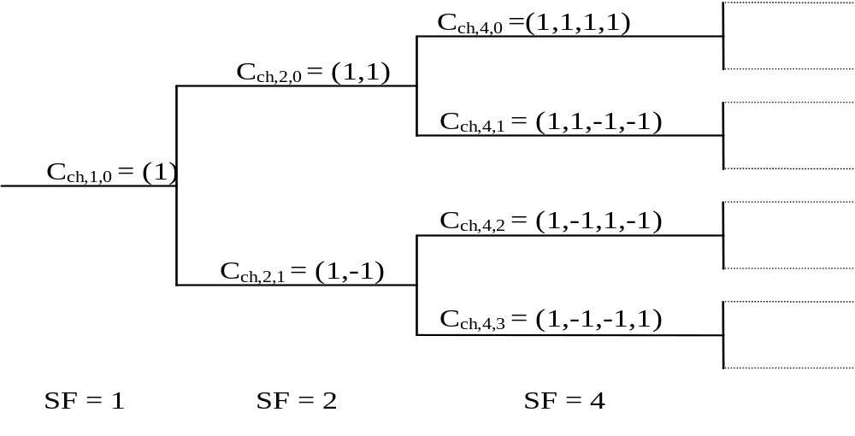
Figure 4: Code-tree for generation of Orthogonal Variable Spreading Factor (OVSF) codes
In figure 4, the channelization codes are uniquely described as C_{ch,SF,k}, where SF is the spreading factor of the code and k is the code number, 0 ≤ k ≤ SF-1.
Each level in the code tree defines channelization codes of length SF, corresponding to a spreading factor of SF in figure 4.
The generation method for the channelization code is defined as:
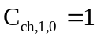,
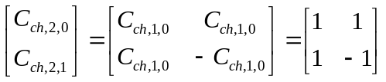
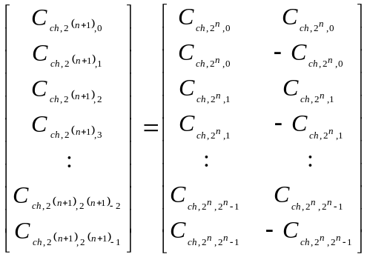
The leftmost value in each channelization code word corresponds to the chip transmitted first in time.

4.3.1.2 Code allocation for DPCCH/DPDCH
For the DPCCH and DPDCHs the following applies:
- The DPCCH is always spread by code c_{c} = C_{ch,256,0.}
- When only one DPDCH is to be transmitted, DPDCH₁ is spread by code c_{d,1} = C_{ch,SF,k} where SF is the spreading factor of DPDCH₁ and k= SF / 4.
- When more than one DPDCH is to be transmitted, all DPDCHs have spreading factors equal to 4. DPDCH_{n} is spread by the the code c_{d,n} = C_{ch,4,k} , where k = 1 if n ∈ {1, 2}, k = 3 if n ∈ {3, 4}, and k = 2 if n ∈ {5, 6}.
If a power control preamble is used to initialise a DCH, the channelisation code for the DPCCH during the power control preamble shall be the same as that to be used afterwards.

4.3.1.3 Code allocation for PRACH message part
The preamble signature s, 0 ≤ s ≤ 15, points to one of the 16 nodes in the code-tree that corresponds to channelization codes of length 16. The sub-tree below the specified node is used for spreading of the message part. The control part is spread with the channelization code c_{c} (as shown in section 4.2.2.2) of spreading factor 256 in the lowest branch of the sub-tree, i.e. c_{c} = C_{ch,256,m} where m = 16×s + 15. The data part uses any of the channelization codes from spreading factor 32 to 256 in the upper-most branch of the sub-tree. To be exact, the data part is spread by channelization code c_{d} = C_{ch,SF,m} and SF is the spreading factor used for the data part and m = SF×s/16.

4.3.1.4 Code allocation for PCPCH message part
For the control part and data part the following applies:
- The control part is always spread by code c_{c}=C_{ch,256,0.}
- The data part is spread by code c_{d}=C_{ch,SF,k} where SF is the spreading factor of the data part and k=SF/4.
The data part may use the code from spreading factor 4 to 256. A UE is allowed to increase SF during the message transmission on a frame by frame basis.

4.3.1.5 Channelisation code for PCPCH power control preamble
The channelisation code for the PCPCH power control preamble is the same as that used for the control part of the message part, as described in section 4.3.1.4 above.

4.3.2 Scrambling codes

4.3.2.1 General
All uplink physical channels are subjected to scrambling with a complex-valued scrambling code. The DPCCH/DPDCH may be scrambled by either long or short scrambling codes, defined in section 4.3.2.4. The PRACH message part is scrambled with a long scrambling code, defined in section 4.3.2.5. Also the PCPCH message part is scrambled with a long scrambling code, defined in section 4.3.2.6.
There are 2²⁴ long and 2²⁴ short uplink scrambling codes. Uplink scrambling codes are assigned by higher layers.
The long scrambling code is built from constituent long sequences defined in section 4.3.2.2, while the constituent short sequences used to build the short scrambling code are defined in section 4.3.2.3.

4.3.2.2 Long scrambling sequence
The long scrambling sequences c_{long,1,n} and c_{long,2,n} are constructed from position wise modulo 2 sum of 38400 chip segments of two binary m-sequences generated by means of two generator polynomials of degree 25. Let x, and y be the two m-sequences respectively. The x sequence is constructed using the primitive (over GF(2)) polynomial X²⁵+X³+1. The y sequence is constructed using the polynomial X²⁵+X³+X²+X+1. The resulting sequences thus constitute segments of a set of Gold sequences.
The sequence c_{long,2,n} is a 16777232 chip shifted version of the sequence c_{long,1,n}.
Let n₂₃ … n₀ be the 24 bit binary representation of the scrambling sequence number n with n₀ being the least significant bit. The x sequence depends on the chosen scrambling sequence number n and is denoted x_{n}, in the sequel. Furthermore, let x_{n}(i) and y(i) denote the i:th symbol of the sequence x_{n} and y, respectively.
The m-sequences x_{n} and y are constructed as:
Initial conditions:
- x_{n}(0)=n₀ , x_{n}(1)= n₁ , … =x_{n}(22)= n₂₂ ,x_{n}(23)= n₂₃, x_{n}(24)=1.
- y(0)=y(1)= … =y(23)= y(24)=1.
Recursive definition of subsequent symbols:
- x_{n}(i+25) =x_{n}(i+3) + x_{n}(i) modulo 2, i=0,…, 2²⁵-27.
- y(i+25) = y(i+3)+y(i+2) +y(i+1) +y(i) modulo 2, i=0,…, 2²⁵-27.
Define the binary Gold sequence z_{n} by:
- z_{n}(i) = x_{n}(i) + y(i) modulo 2, i = 0, 1, 2, …, 2²⁵-2.
The real valued Gold sequence Z_{n} is defined by:
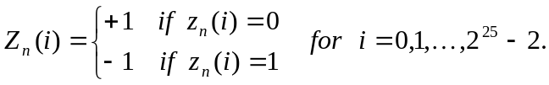
Now, the real-valued long scrambling sequences c_{long,1,n} and c_{long,2,n} are defined as follows:
c_{long,1,n}(i) = Z_{n}(i), i = 0, 1, 2, …, 2²⁵ – 2 and
c_{long,2,n}(i) = Z_{n}((i + 16777232) modulo (2²⁵ – 1)), i = 0, 1, 2, …, 2²⁵ – 2.
Finally, the complex-valued long scrambling sequence C_{long, n}, is defined as:
where i = 0, 1, …, 2²⁵ – 2 and ⎣⎦ denotes rounding to nearest lower integer.

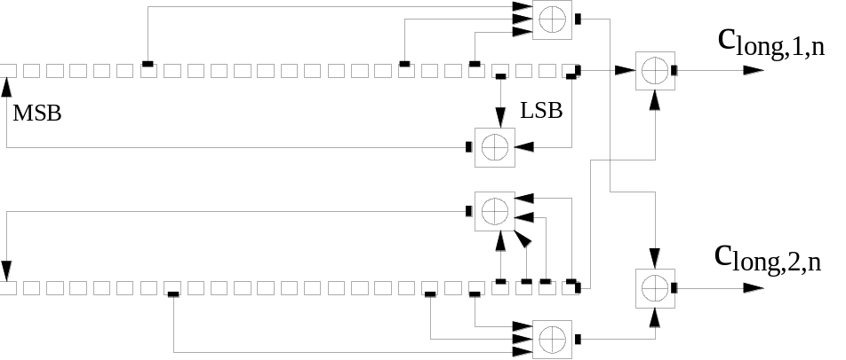
Figure 5: Configuration of uplink scrambling sequence generator

4.3.2.3 Short scrambling sequence
The short scrambling sequences c_{short,1,n}(i) and c_{short,2,n}(i) are defined from a sequence from the family of periodically extended S(2) codes.
Let n₂₃n₂₂…n₀ be the 24 bit binary representation of the code number n.
The n:th quaternary S(2) sequence z_{n}(i), 0 ≤ n ≤ 16777215, is obtained by modulo 4 addition of three sequences, a quaternary sequence a(i) and two binary sequences b(i) and d(i), where the initial loading of the three sequences is determined from the code number n. The sequence z_{n}(i) of length 255 is generated according to the following relation:
- z_{n}(i) = a(i) + 2b(i) + 2d(i) modulo 4, i = 0, 1, …, 254;

where the quaternary sequence a(i) is generated recursively by the polynomial g₀(x)= x⁸+x⁵+3x³+x²+2x+1 as:
- a(0) = 2n₀ + 1 modulo 4;
- a(i) = 2n_{i} modulo 4, i = 1, 2, …, 7;
- a(i) = 3a(i-3) + a(i-5) + 3a(i-6) + 2a(i-7) + 3a(i-8) modulo 4, i = 8, 9, …, 254;

and the binary sequence b(i) is generated recursively by the polynomial g₁(x)= x⁸+x⁷+x⁵+x+1 as
b(i) = n_{8+i} modulo 2, i = 0, 1, …, 7,
b(i) = b(i-1) + b(i-3) + b(i-7) + b(i-8) modulo 2, i = 8, 9, …, 254,

and the binary sequence d(i) is generated recursively by the polynomial g₂(x)= x⁸+x⁷+x⁵+x⁴+1 as:
d(i) = n_{16+i} modulo 2, i = 0, 1, …, 7;
d(i) = d(i-1) + d(i-3) + d(i-4) + d(i-8) modulo 2, i = 8, 9, …, 254.
The sequence z_{n}(i) is extended to length 256 chips by setting z_{n}(255) = z_{n}(0).
The mapping from z_{n}(i) to the real-valued binary sequences c_{short,1,n}(i) and c_{short,2,n}(i), , i = 0, 1, …, 255 is defined in Table 2.
Table 2: Mapping from z_{n}(i) to c_{short,1,n}(i) and c_{short,2,n}(i), i = 0, 1, …, 255
z_{n}(i) | c_{short,1,n}(i) | c_{short,2,n}(i)
0 | +1 | +1
1 | -1 | +1
2 | -1 | -1
3 | +1 | -1

Finally, the complex-valued short scrambling sequence C_{short, n}, is defined as:
where i = 0, 1, 2, … and ⎣⎦ denotes rounding to nearest lower integer.
An implementation of the short scrambling sequence generator for the 255 chip sequence to be extended by one chip is shown in Figure 6.
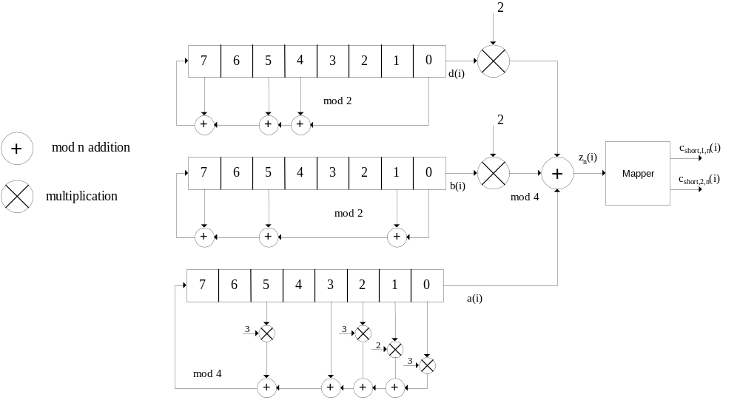
Figure 6: Uplink short scrambling sequence generator for 255 chip sequence

4.3.2.4 DPCCH/DPDCH scrambling code
The code used for scrambling of the uplink DPCCH/DPDCH may be of either long or short type. When the scrambling code is formed, different consituent codes are used for the long and short type as defined below.
The n:th uplink scrambling code for DPCCH/DPDCH, denoted S_{dpch, n}, is defined as:
S_{dpch,n}(i) = C_{long,n}(i), i = 0, 1, …, 38399, when using long scrambling codes;
where the lowest index corresponds to the chip transmitted first in time and C_{long,n} is defined in section 4.3.2.2.
The n:th uplink scrambling code for DPCCH/DPDCH, denoted S_{dpch, n}, is defined as:
S_{dpch,n}(i) = C_{short,n}(i), i = 0, 1, …, 38399, when using short scrambling codes;
where the lowest index corresponds to the chip transmitted first in time and C_{short,n} is defined in section 4.3.2.3.
If a power control preamble is used to initialise a DCH, the scrambling code for the DPCCH during the power control preamble shall be the same as that to be used afterwards. The phase of the scrambling code shall be such that the end of the code is aligned with the frame boundary at the end of the power control preamble.

4.3.2.5 PRACH message part scrambling code
The scrambling code used for the PRACH message part is 10 ms long, and there are 8192 different PRACH scrambling codes defined.
The n:th PRACH message part scrambling code, denoted S_{r-msg,n}, where n = 0, 1, …, 8191, is based on the long scrambling sequence and is defined as:
S_{r-msg,n}(i) = C_{long,n}(i + 4096), i = 0, 1, …, 38399
where the lowest index corresponds to the chip transmitted first in time and C_{long,n} is defined in section 4.3.2.2.
The message part scrambling code has a one-to-one correspondence to the scrambling code used for the preamble part. For one PRACH, the same code number is used for both scrambling codes, i.e. if the PRACH preamble scrambling code used is S_{r-pre,m} then the PRACH message part scrambling code is S_{r-msg,m}, where the number m is the same for both codes.

4.3.2.6 PCPCH message part scrambling code
The set of scrambling codes used for the PCPCH message part are 10 ms long, cell-specific, and each scrambling code has a one-to-one correspondence to the signature sequence and the access sub-channel used by the access preamble part. Both long or short scrambling codes can be used to scramble the CPCH message part. There are 64 uplink scrambling codes defined per cell and 32768 different PCPCH scrambling codes defined in the system.
The n:th PCPCH message part scrambling code, denoted S_{c-msg,,n}, where n =8192,8193, …,40959 is based on the scrambling sequence and is defined as:
In the case when the long scrambling codes are used:
S_{c-msg,n}(i) = C_{long,n}(i ), i = 0, 1, …, 38399
where the lowest index corresponds to the chip transmitted first in time and C_{long,n} is defined in section 4.3.2.2.
In the case the short scrambling codes are used:
S_{c-msg,n}(i) = C_{short,n}(i), i = 0, 1, …, 38399
The 32768 PCPCH scrambling codes are divided into 512 groups with 64 codes in each group. There is a one-to-one correspondence between the group of PCPCH preamble scrambling codes in a cell and the primary scrambling code used in the downlink of the cell. The k:th PCPCH scrambling code within the cell with downlink primary scrambling code m, k =16,17,…, 79 and m = 0, 1, 2, …, 511, is S_{c-msg, n} as defined above with n = 64×m + k+8176.

4.3.2.7 PCPCH power control preamble scrambling code
The scrambling code for the PCPCH power control preamble is the same as for the PCPCH message part, as described in section 4.2.3.6 above. The phase of the scrambling code shall be such that the end of the code is aligned with the frame boundary at the end of the power control preamble.

4.3.3 PRACH preamble codes

4.3.3.1 Preamble code construction
The random access preamble code C_{pre,n,} is a complex valued sequence. It is built from a preamble scrambling code S_{r-pre,n} and a preamble signature C_{sig,s} as follows:
- C_{pre,n,s}(k) = S_{r-pre,n}(k) × C_{sig,s}(k) × 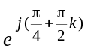, k = 0, 1, 2, 3, …, 4095;
where k=0 corresponds to the chip transmitted first in time and S_{r-pre,n} and C_{sig,s} are defined in 4.3.3.2 and 4.3.3.3 below respectively.

4.3.3.2 Preamble scrambling code
The scrambling code for the PRACH preamble part is constructed from the long scrambling sequences. There are 8192 PRACH preamble scrambling codes in total.
The n:th preamble scrambling code, n = 0, 1, …, 8191, is defined as:
S_{r-pre,n}(i) = c_{long,1,n}(i), i = 0, 1, …, 4095;
where the sequence c_{long,1,n} is defined in section 4.3.2.2.
The 8192 PRACH preamble scrambling codes are divided into 512 groups with 16 codes in each group. There is a one-to-one correspondence between the group of PRACH preamble scrambling codes in a cell and the primary scrambling code used in the downlink of the cell. The k:th PRACH preamble scrambling code within the cell with downlink primary scrambling code m, k = 0, 1, 2, …, 15 and m = 0, 1, 2, …, 511, is S_{r-pre,n}(i) as defined above with n = 16×m + k.

4.3.3.3 Preamble signature
The preamble signature corresponding to a signature s consists of 256 repetitions of a length 16 signature P_{s}(n), n=0…15. This is defined as follows:
- C_{sig,s}(i) = P_{s}(i modulo 16), i = 0, 1, …, 4095.
The signature P_{s}(n) is from the set of 16 Hadamard codes of length 16. These are listed in table 3.
Table 3: Preamble signatures
Preamble  signature | Value of n
Preamble  signature | 0 | 1 | 2 | 3 | 4 | 5 | 6 | 7 | 8 | 9 | 10 | 11 | 12 | 13 | 14 | 15
P₀(n) | 1 | 1 | 1 | 1 | 1 | 1 | 1 | 1 | 1 | 1 | 1 | 1 | 1 | 1 | 1 | 1
P₁(n) | 1 | -1 | 1 | -1 | 1 | -1 | 1 | -1 | 1 | -1 | 1 | -1 | 1 | -1 | 1 | -1
P₂(n) | 1 | 1 | -1 | -1 | 1 | 1 | -1 | -1 | 1 | 1 | -1 | -1 | 1 | 1 | -1 | -1
P₃(n) | 1 | -1 | -1 | 1 | 1 | -1 | -1 | 1 | 1 | -1 | -1 | 1 | 1 | -1 | -1 | 1
P₄(n) | 1 | 1 | 1 | 1 | -1 | -1 | -1 | -1 | 1 | 1 | 1 | 1 | -1 | -1 | -1 | -1
P₅(n) | 1 | -1 | 1 | -1 | -1 | 1 | -1 | 1 | 1 | -1 | 1 | -1 | -1 | 1 | -1 | 1
P₆(n) | 1 | 1 | -1 | -1 | -1 | -1 | 1 | 1 | 1 | 1 | -1 | -1 | -1 | -1 | 1 | 1
P₇(n) | 1 | -1 | -1 | 1 | -1 | 1 | 1 | -1 | 1 | -1 | -1 | 1 | -1 | 1 | 1 | -1
P₈(n) | 1 | 1 | 1 | 1 | 1 | 1 | 1 | 1 | -1 | -1 | -1 | -1 | -1 | -1 | -1 | -1
P₉(n) | 1 | -1 | 1 | -1 | 1 | -1 | 1 | -1 | -1 | 1 | -1 | 1 | -1 | 1 | -1 | 1
P₁₀(n) | 1 | 1 | -1 | -1 | 1 | 1 | -1 | -1 | -1 | -1 | 1 | 1 | -1 | -1 | 1 | 1
P₁₁(n) | 1 | -1 | -1 | 1 | 1 | -1 | -1 | 1 | -1 | 1 | 1 | -1 | -1 | 1 | 1 | -1
P₁₂(n) | 1 | 1 | 1 | 1 | -1 | -1 | -1 | -1 | -1 | -1 | -1 | -1 | 1 | 1 | 1 | 1
P₁₃(n) | 1 | -1 | 1 | -1 | -1 | 1 | -1 | 1 | -1 | 1 | -1 | 1 | 1 | -1 | 1 | -1
P₁₄(n) | 1 | 1 | -1 | -1 | -1 | -1 | 1 | 1 | -1 | -1 | 1 | 1 | 1 | 1 | -1 | -1
P₁₅(n) | 1 | -1 | -1 | 1 | -1 | 1 | 1 | -1 | -1 | 1 | 1 | -1 | 1 | -1 | -1 | 1

4.3.4 PCPCH preamble codes

4.3.4.1 Access preamble

4.3.4.1.1 Access preamble code construction
Similar to PRACH access preamble codes, the PCPCH access preamble codes C_{c-acc,n,s}, are complex valued sequences. The PCPCH access preamble codes are built from the preamble scrambling codes S_{c-acc,n} and a preamble signature C_{sig,s} as follows:
- C_{c-acc,n,s}(k) = S_{c-acc,n}(k) × C_{sig,s}(k) × , k = 0, 1, 2, 3, …, 4095;
- where S_{c-acc,n} and C_{sig,s} are defined in section 4.3.4.1.2 and 4.3.4.1.3 below respectively.

4.3.4.1.2 Access preamble scrambling code
The scrambling code for the PCPCH preamble part is constructed from the long scrambling sequences. There are 40960 PCPCH access preamble scrambling codes in total.
The n:th PCPCH access preamble scrambling code, where n = 0, ..., 40959 is defined as:
- S_{c-acc,n} (i) = c_{long,1,n}(i), i = 0, 1, …, 4095;
where the sequence c_{long,1,n} is defined in section 4.3.2.2.
The 40960 PCPCH access preamble scrambling codes are divided into 512 groups with 80 codes in each group. There is a one-to-one correspondence between the group of PCPCH access preamble scrambling codes in a cell and the primary scrambling code used in the downlink of the cell. The k:th PCPCH scrambling code within the cell with downlink primary scrambling code m, for k = 0,..., 79 and m = 0, 1, 2, …, 511, is S_{c-acc, n} as defined above with n=16 ×m+k for k=0,...,15 and n = 64×m + (k-16)+8192 for k=16,..., 79.
The index k = 0,...,15 may only be used as a PCPCH access preamble part scrambling code if the same code is also used for a PRACH.
The index k=16,..., 79 correspond to PCPCH access preamble scrambling codes which are not shared together with a PRACH. This leads to 32768 PCPCH specific preamble scrambling codes divided into 512 groups with 64 elements.

4.3.4.1.3 Access preamble signature
The access preamble part of the CPCH-access burst carries one of the sixteen different orthogonal complex signatures identical to the ones used by the preamble part of the random-access burst.

4.3.4.2 CD preamble

4.3.4.2.1 CD preamble code construction
Similar to PRACH access preamble codes, the PCPCH CD preamble codes C_{c-cd,n,s} are complex valued sequences. The PCPCH CD preamble codes are built from the preamble scrambling codes Sc-cd,n and a preamble signature C_{sig,s} as follows:
- C_{c-cd,n,s}(k) = S_{c-cd,n}(k) × C_{sig,s}(k) × , k = 0, 1, 2, 3, …, 4095;
where S_{c-cd,n} and C_{sig,s} are defined in sections 4.3.4.2.2 and 4.3.4.2.3 below respectively.

4.3.4.2.2 CD preamble scrambling code
There are 40960 PCPCH-CD preamble scrambling codes in total.
The n:th PCPCH CD access preamble scrambling code, where n = 0 ,..., 40959, is defined as:
- S_{c-cd,n}(i) = c_{long,1,n}(i), i = 0, 1, …, 4095;
where the sequence c_{long,1,n} is defined in section 4.3.2.2.
The 40960 PCPCH scrambling codes are divided into 512 groups with 80 codes in each group. There is a one-to-one correspondence between the group of PCPCH CD preamble scrambling codes in a cell and the primary scrambling code used in the downlink of the cell. The k:th PCPCH scrambling code within the cell with downlink primary scrambling code m, k = 0,1, …, 79 and m = 0, 1, 2, …, 511, is S_{c-cd, n} as defined above with n=16×m+k for k = 0,...,15 and n = 64×m + (k-16)+8192 for k=16,...,79.
The index k=0,...,15 may only be used as a PCPCH CD preamble part scrambling code if the same code is also used for a PRACH.
The index k=16,..., 79 correspond to PCPCH CD preamble scrambling codes which are not shared together with a PRACH. This leads to 32768 PCPCH specific preamble scrambling codes divided into 512 groups with 64 elements.

4.3.4.2.3 CD preamble signature
The CD-preamble part of the CPCH-access burst carries one of sixteen different orthogonal complex signatures identical to the ones used by the preamble part of the random-access burst.

4.4 Modulation

4.4.1 Modulating chip rate
The modulating chip rate is 3.84 Mcps.

4.4.2 Modulation
In the uplink, the complex-valued chip sequence generated by the spreading process is QPSK modulated as shown in Figure 7 below:
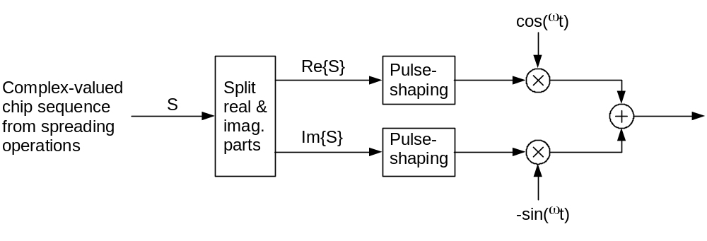
Figure 7: Uplink modulation
The pulse-shaping characteristics are described in [3].

5 Downlink spreading and modulation

5.1 Spreading
Figure 8 illustrates the spreading operation for all downlink physical channels except SCH, i.e. for P-CCPCH, S-CCPCH, CPICH, AICH, PICH, PDSCH,and downlink DPCH. The non-spread physical channel consists of a sequence of real-valued symbols. For all channels except AICH, the symbols can take the three values +1, -1, and 0, where 0 indicates DTX. For AICH, the symbol values depend on the exact combination of acquisition indicators to be transmitted, compare [2] Section 5.3.3.6.
Each pair of two consecutive symbols is first serial-to-parallel converted and mapped to an I and Q branch. The mapping is such that even and odd numbered symbols are mapped to the I and Q branch respectively. For all channels except AICH, symbol number zero is defined as the first symbol in each frame. For AICH, symbol number zero is defined as the first symbol in each access slot. The I and Q branches are then spread to the chip rate by the same real-valued channelization code C_{ch,SF,m}. The sequences of real-valued chips on the I and Q branch are then treated as a single complex-valued sequence of chips. This sequence of chips is scrambled (complex chip-wise multiplication) by a complex-valued scrambling code S_{dl,n}. In case of P-CCPCH, the scrambling code is applied aligned with the P-CCPCH frame boundary, i.e. the first complex chip of the spread P-CCPCH frame is multiplied with chip number zero of the scrambling code. In case of other downlink channels, the scrambling code is applied aligned with the scrambling code applied to the P-CCPCH. In this case, the scrambling code is thus not necessarily applied aligned with the frame boundary of the physical channel to be scrambled.
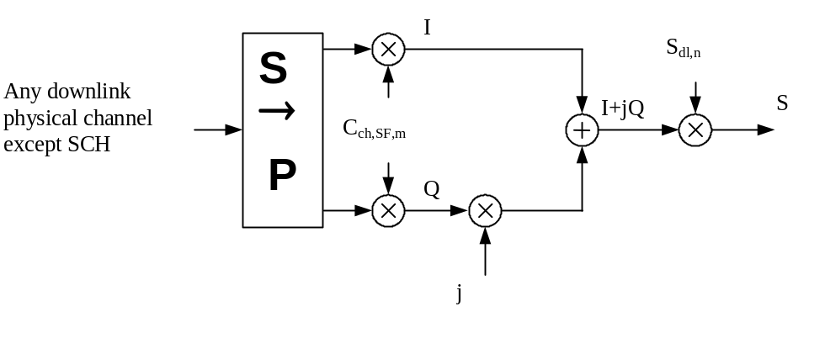
Figure 8: Spreading for all downlink physical channels except SCH
Figure 9 illustrates how different downlink channels are combined. Each complex-valued spread channel, corresponding to point S in Figure 8, is separately weighted by a weight factor G_{i}. The complex-valued P-SCH and S-SCH, as described in [1], section 5.3.3.4, are separately weighted by weight factors G_{p} and G_{s}. All downlink physical channels are then combined using complex addition.
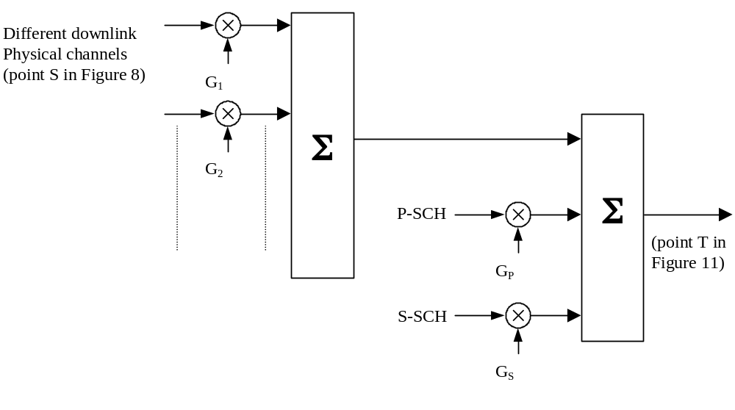
Figure 9: Spreading and modulation for SCH and P-CCPCH

5.2 Code generation and allocation

5.2.1 Channelization codes
The channelization codes of figure 8 are the same codes as used in the uplink, namely Orthogonal Variable Spreading Factor (OVSF) codes that preserve the orthogonality between downlink channels of different rates and spreading factors. The OVSF codes are defined in figure 4 in section 4.3.1.
The channelization code for the Primary CPICH is fixed to C_{ch,256,0} and the channelization code for the Primary CCPCH is fixed to C_{ch,256,1}.The channelization codes for all other physical channels are assigned by UTRAN.
With the spreading factor 512 a specific restriction is applied. When the code word C_{ch,512,n}, with n=0,2,4….510, is used in soft handover, then the code word C_{ch,512,n+1} is not allocated in the Node Bs where timing adjustment is to be used. Respectively if C_{ch,512,n}, with n=1,3,5….511 is used, then the code word C_{ch,512,n-1} is not allocated in the Node B where timing adjustment is to be used. This restriction shall not apply for the softer handover operation or in case UTRAN is synchronised to such a level that timing adjustments in soft handover are not used with spreading factor 512.
When compressed mode is implemented by reducing the spreading factor by 2, the OVSF code used for compressed frames is:
- C_{ch,SF/2,⎣n/2⎦} if ordinary scrambling code is used.
- C_{ch,SF/2,n mod SF/2} if alternative scrambling code is used (see section 5.2.2);
where C_{ch,SF,n} is the channelization code used for non-compressed frames.
In case the OVSF code on the PDSCH varies from frame to frame, the OVSF codes shall be allocated such a way that the OVSF code(s) below the smallest spreading factor will be from the branch of the code tree pointed by the smallest spreading factor used for the connection. This means that all the codes for UE for the PDSCH connection can be generated according to the OVSF code generation principle from smallest spreading factor code used by the UE on PDSCH.
In case of mapping the DSCH to multiple parallel PDSCHs, the same rule applies, but all of the branches identified by the multiple codes, corresponding to the smallest spreading factor, may be used for higher spreading factor allocation.

5.2.2 Scrambling code
A total of 2¹⁸-1 = 262,143 scrambling codes, numbered 0…262,142 can be generated. However not all the scrambling codes are used. The scrambling codes are divided into 512 sets each of a primary scrambling code and 15 secondary scrambling codes.
The primary scrambling codes consist of scrambling codes n=16*i where i=0…511. The i:th set of secondary scrambling codes consists of scrambling codes 16*i+k, where k=1…15.
There is a one-to-one mapping between each primary scrambling code and 15 secondary scrambling codes in a set such that i:th primary scrambling code corresponds to i:th set of secondary scrambling codes.
Hence, according to the above, scrambling codes k = 0, 1, …, 8191 are used. Each of these codes are associated with a left alternative scrambling code and a right alternative scrambling code, that may be used for compressed frames. The left alternative scrambling code corresponding to scrambling code k is scrambling code number k + 8192, while the right alternative scrambling code corresponding to scrambling code k is scrambling code number k + 16384. The alternative scrambling codes can be used for compressed frames. In this case, the left alternative scrambling code is used if n<SF/2 and the right alternative scrambling code is used if n≥SF/2, where c_{ch,SF,n} is the channelization code used for non-compressed frames. The usage of alternative scrambling code for compressed frames is signalled by higher layers for each physical channel respectively.
The set of primary scrambling codes is further divided into 64 scrambling code groups, each consisting of 8 primary scrambling codes. The j:th scrambling code group consists of primary scrambling codes 16*8*j+16*k, where j=0..63 and k=0..7.
Each cell is allocated one and only one primary scrambling code. The primary CCPCH, primary CPICH, PICH, AICH, AP-AICH, CD/CA-ICH, CSICH and S-CCPCH carrying PCH are always transmitted using the primary scrambling code. The other downlink physical channels can be transmitted with either the primary scrambling code or a secondary scrambling code from the set associated with the primary scrambling code of the cell.
The mixture of primary scrambling code and secondary scrambling code for one CCTrCH is allowable. However, in the case of the CCTrCH of type DSCH then all the PDSCH channelisation codes that a single UE may receive shall be under a single scrambling code (either the primary or a secondary scrambling code).
The scrambling code sequences are constructed by combining two real sequences into a complex sequence. Each of the two real sequences are constructed as the position wise modulo 2 sum of 38400 chip segments of two binary m-sequences generated by means of two generator polynomials of degree 18. The resulting sequences thus constitute segments of a set of Gold sequences. The scrambling codes are repeated for every 10 ms radio frame. Let x and y be the two sequences respectively. The x sequence is constructed using the primitive (over GF(2)) polynomial 1+X⁷+X¹⁸ . The y sequence is constructed using the polynomial 1+X⁵+X⁷+ X¹⁰+X¹⁸ .
The sequence depending on the chosen scrambling code number n is denoted z_{n}, in the sequel. Furthermore, let x(i), y(i) and z_{n}(i) denote the i:th symbol of the sequence x, y, and z_{n}, respectively.
The m-sequences xand y are constructed as:
Initial conditions:
- x is constructed with x (0)=1, x(1)= x(2)=...= x (16)= x (17)=0.
- y(0)=y(1)= … =y(16)= y(17)=1.
Recursive definition of subsequent symbols:
- x(i+18) =x(i+7) + x(i) modulo 2, i=0,…,2¹⁸-20.
- y(i+18) = y(i+10)+y(i+7)+y(i+5)+y(i) modulo 2, i=0,…, 2¹⁸-20.
The n:th Gold code sequence z_{n}, n=0,1,2,…,2¹⁸-2, is then defined as:
- z_{n}(i) = x((i+n) modulo (2¹⁸ - 1)) + y(i) modulo 2, i=0,…, 2¹⁸-2.
These binary sequences are converted to real valued sequences Z_{n} by the following transformation:
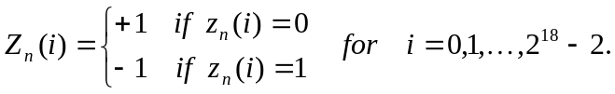
Finally, the n:th complex scrambling code sequence S_{dl,n} is defined as:
- S_{dl,n}(i) = Z_{n}(i) + j Z_{n}((i+131072) modulo (2¹⁸-1)), i=0,1,…,38399.
Note that the pattern from phase 0 up to the phase of 38399 is repeated.
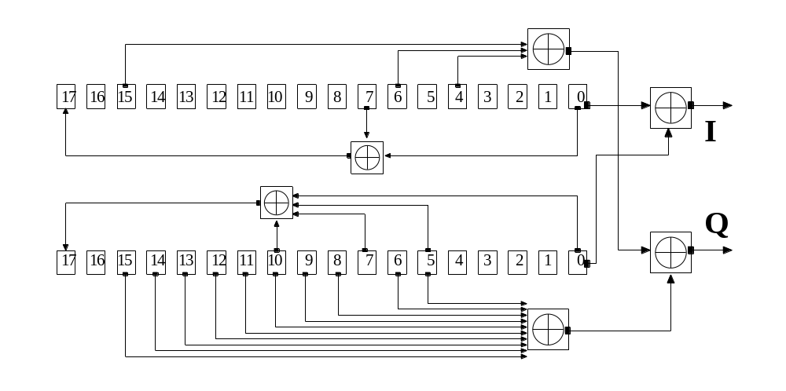
Figure 10: Configuration of downlink scrambling code generator

5.2.3 Synchronisation codes

5.2.3.1 Code generation
The primary synchronisation code (PSC), C_{psc} is constructed as a so-called generalised hierarchical Golay sequence. The PSC is furthermore chosen to have good aperiodic auto correlation properties.
Define:
- a = <x₁, x₂, x₃, …, x₁₆> = <1, 1, 1, 1, 1, 1, -1, -1, 1, -1, 1, -1, 1, -1, -1, 1>
The PSC is generated by repeating the sequence a modulated by a Golay complementary sequence, and creating a complex-valued sequence with identical real and imaginary components. The PSC C_{psc} is defined as:
- C_{psc} = (1 + j) × <a, a, a, -a, -a, a, -a, -a, a, a, a, -a, a, -a, a, a>;
where the leftmost chip in the sequence corresponds to the chip transmitted first in time.
The 16 secondary synchronization codes (SSCs), {C_{ssc,1},…,C _{ssc,16}}, are complex-valued with identical real and imaginary components, and are constructed from position wise multiplicationof a Hadamard sequence and a sequence z, defined as:
- z = <b, b, b, -b, b, b, -b, -b, b, -b, b, -b, -b, -b, -b, -b>, where
- b = <x₁, x₂, x₃, x₄, x₅, x₆, x₇, x₈, -x₉, -x₁₀, -x₁₁, -x₁₂, -x₁₃, -x₁₄, -x_{15,} -x₁₆> and x_{1,} x₂ , …, x_{15,} x_{16,} are same as in the definition of the sequence a above.
The Hadamard sequences are obtained as the rows in a matrix H₈ constructed recursively by:
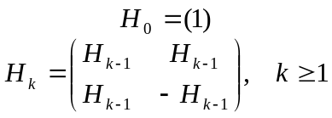
The rows are numbered from the top starting with row 0 (the all ones sequence).
Denote the n:th Hadamard sequence as a row of H₈ numbered from the top, n = 0, 1, 2, …, 255, in the sequel.
Furthermore, let h_{n}(i) and z(i) denote the i:th symbol of the sequence h_{n} and z, respectively where i = 0, 1, 2, …, 255 and i = 0 corresponds to the leftmost symbol.
The k:th SSC, C_{ssc,k}, k = 1, 2, 3, …, 16 is then defined as:
- C_{ssc,k} = (1 + j) × <h_{m}(0) × z(0), h_{m}(1) × z(1), h_{m}(2) × z(2), …, h_{m}(255) × z(255)>;
where m = 16×(k – 1) and the leftmost chip in the sequence corresponds to the chip transmitted first in time.

5.2.3.2 Code allocation of SSC
The 64 secondary SCH sequences are constructed such that their cyclic-shifts are unique, i.e., a non-zero cyclic shift less than 15 of any of the 64 sequences is not equivalent to some cyclic shift of any other of the 64 sequences. Also, a non-zero cyclic shift less than 15 of any of the sequences is not equivalent to itself with any other cyclic shift less than 15. Table 4 describes the sequences of SSCs used to encode the 64 different scrambling code groups. The entries in table 4 denote what SSC to use in the different slots for the different scrambling code groups, e.g. the entry "7" means that SSC C_{ssc,7} shall be used for the corresponding scrambling code group and slot.
Table 4: Allocation of SSCs for secondary SCH
Scrambling  Code Group | slot number
Scrambling  Code Group | #0 | #1 | #2 | #3 | #4 | #5 | #6 | #7 | #8 | #9 | #10 | #11 | #12 | #13 | #14
Group 0 | 1 | 1 | 2 | 8 | 9 | 10 | 15 | 8 | 10 | 16 | 2 | 7 | 15 | 7 | 16
Group 1 | 1 | 1 | 5 | 16 | 7 | 3 | 14 | 16 | 3 | 10 | 5 | 12 | 14 | 12 | 10
Group 2 | 1 | 2 | 1 | 15 | 5 | 5 | 12 | 16 | 6 | 11 | 2 | 16 | 11 | 15 | 12
Group 3 | 1 | 2 | 3 | 1 | 8 | 6 | 5 | 2 | 5 | 8 | 4 | 4 | 6 | 3 | 7
Group 4 | 1 | 2 | 16 | 6 | 6 | 11 | 15 | 5 | 12 | 1 | 15 | 12 | 16 | 11 | 2
Group 5 | 1 | 3 | 4 | 7 | 4 | 1 | 5 | 5 | 3 | 6 | 2 | 8 | 7 | 6 | 8
Group 6 | 1 | 4 | 11 | 3 | 4 | 10 | 9 | 2 | 11 | 2 | 10 | 12 | 12 | 9 | 3
Group 7 | 1 | 5 | 6 | 6 | 14 | 9 | 10 | 2 | 13 | 9 | 2 | 5 | 14 | 1 | 13
Group 8 | 1 | 6 | 10 | 10 | 4 | 11 | 7 | 13 | 16 | 11 | 13 | 6 | 4 | 1 | 16
Group 9 | 1 | 6 | 13 | 2 | 14 | 2 | 6 | 5 | 5 | 13 | 10 | 9 | 1 | 14 | 10
Group 10 | 1 | 7 | 8 | 5 | 7 | 2 | 4 | 3 | 8 | 3 | 2 | 6 | 6 | 4 | 5
Group 11 | 1 | 7 | 10 | 9 | 16 | 7 | 9 | 15 | 1 | 8 | 16 | 8 | 15 | 2 | 2
Group 12 | 1 | 8 | 12 | 9 | 9 | 4 | 13 | 16 | 5 | 1 | 13 | 5 | 12 | 4 | 8
Group 13 | 1 | 8 | 14 | 10 | 14 | 1 | 15 | 15 | 8 | 5 | 11 | 4 | 10 | 5 | 4
Group 14 | 1 | 9 | 2 | 15 | 15 | 16 | 10 | 7 | 8 | 1 | 10 | 8 | 2 | 16 | 9
Group 15 | 1 | 9 | 15 | 6 | 16 | 2 | 13 | 14 | 10 | 11 | 7 | 4 | 5 | 12 | 3
Group 16 | 1 | 10 | 9 | 11 | 15 | 7 | 6 | 4 | 16 | 5 | 2 | 12 | 13 | 3 | 14
Group 17 | 1 | 11 | 14 | 4 | 13 | 2 | 9 | 10 | 12 | 16 | 8 | 5 | 3 | 15 | 6
Group 18 | 1 | 12 | 12 | 13 | 14 | 7 | 2 | 8 | 14 | 2 | 1 | 13 | 11 | 8 | 11
Group 19 | 1 | 12 | 15 | 5 | 4 | 14 | 3 | 16 | 7 | 8 | 6 | 2 | 10 | 11 | 13
Group 20 | 1 | 15 | 4 | 3 | 7 | 6 | 10 | 13 | 12 | 5 | 14 | 16 | 8 | 2 | 11
Group 21 | 1 | 16 | 3 | 12 | 11 | 9 | 13 | 5 | 8 | 2 | 14 | 7 | 4 | 10 | 15
Group 22 | 2 | 2 | 5 | 10 | 16 | 11 | 3 | 10 | 11 | 8 | 5 | 13 | 3 | 13 | 8
Group 23 | 2 | 2 | 12 | 3 | 15 | 5 | 8 | 3 | 5 | 14 | 12 | 9 | 8 | 9 | 14
Group 24 | 2 | 3 | 6 | 16 | 12 | 16 | 3 | 13 | 13 | 6 | 7 | 9 | 2 | 12 | 7
Group 25 | 2 | 3 | 8 | 2 | 9 | 15 | 14 | 3 | 14 | 9 | 5 | 5 | 15 | 8 | 12
Group 26 | 2 | 4 | 7 | 9 | 5 | 4 | 9 | 11 | 2 | 14 | 5 | 14 | 11 | 16 | 16
Group 27 | 2 | 4 | 13 | 12 | 12 | 7 | 15 | 10 | 5 | 2 | 15 | 5 | 13 | 7 | 4
Group 28 | 2 | 5 | 9 | 9 | 3 | 12 | 8 | 14 | 15 | 12 | 14 | 5 | 3 | 2 | 15
Group 29 | 2 | 5 | 11 | 7 | 2 | 11 | 9 | 4 | 16 | 7 | 16 | 9 | 14 | 14 | 4
Group 30 | 2 | 6 | 2 | 13 | 3 | 3 | 12 | 9 | 7 | 16 | 6 | 9 | 16 | 13 | 12
Group 31 | 2 | 6 | 9 | 7 | 7 | 16 | 13 | 3 | 12 | 2 | 13 | 12 | 9 | 16 | 6
Group 32 | 2 | 7 | 12 | 15 | 2 | 12 | 4 | 10 | 13 | 15 | 13 | 4 | 5 | 5 | 10
Group 33 | 2 | 7 | 14 | 16 | 5 | 9 | 2 | 9 | 16 | 11 | 11 | 5 | 7 | 4 | 14
Group 34 | 2 | 8 | 5 | 12 | 5 | 2 | 14 | 14 | 8 | 15 | 3 | 9 | 12 | 15 | 9
Group 35 | 2 | 9 | 13 | 4 | 2 | 13 | 8 | 11 | 6 | 4 | 6 | 8 | 15 | 15 | 11
Group 36 | 2 | 10 | 3 | 2 | 13 | 16 | 8 | 10 | 8 | 13 | 11 | 11 | 16 | 3 | 5
Group 37 | 2 | 11 | 15 | 3 | 11 | 6 | 14 | 10 | 15 | 10 | 6 | 7 | 7 | 14 | 3
Group 38 | 2 | 16 | 4 | 5 | 16 | 14 | 7 | 11 | 4 | 11 | 14 | 9 | 9 | 7 | 5
Group 39 | 3 | 3 | 4 | 6 | 11 | 12 | 13 | 6 | 12 | 14 | 4 | 5 | 13 | 5 | 14
Group 40 | 3 | 3 | 6 | 5 | 16 | 9 | 15 | 5 | 9 | 10 | 6 | 4 | 15 | 4 | 10
Group 41 | 3 | 4 | 5 | 14 | 4 | 6 | 12 | 13 | 5 | 13 | 6 | 11 | 11 | 12 | 14
Group 42 | 3 | 4 | 9 | 16 | 10 | 4 | 16 | 15 | 3 | 5 | 10 | 5 | 15 | 6 | 6
Group 43 | 3 | 4 | 16 | 10 | 5 | 10 | 4 | 9 | 9 | 16 | 15 | 6 | 3 | 5 | 15
Group 44 | 3 | 5 | 12 | 11 | 14 | 5 | 11 | 13 | 3 | 6 | 14 | 6 | 13 | 4 | 4
Group 45 | 3 | 6 | 4 | 10 | 6 | 5 | 9 | 15 | 4 | 15 | 5 | 16 | 16 | 9 | 10
Group 46 | 3 | 7 | 8 | 8 | 16 | 11 | 12 | 4 | 15 | 11 | 4 | 7 | 16 | 3 | 15
Group 47 | 3 | 7 | 16 | 11 | 4 | 15 | 3 | 15 | 11 | 12 | 12 | 4 | 7 | 8 | 16
Group 48 | 3 | 8 | 7 | 15 | 4 | 8 | 15 | 12 | 3 | 16 | 4 | 16 | 12 | 11 | 11
Group 49 | 3 | 8 | 15 | 4 | 16 | 4 | 8 | 7 | 7 | 15 | 12 | 11 | 3 | 16 | 12
Group 50 | 3 | 10 | 10 | 15 | 16 | 5 | 4 | 6 | 16 | 4 | 3 | 15 | 9 | 6 | 9
Group 51 | 3 | 13 | 11 | 5 | 4 | 12 | 4 | 11 | 6 | 6 | 5 | 3 | 14 | 13 | 12
Group 52 | 3 | 14 | 7 | 9 | 14 | 10 | 13 | 8 | 7 | 8 | 10 | 4 | 4 | 13 | 9
Group 53 | 5 | 5 | 8 | 14 | 16 | 13 | 6 | 14 | 13 | 7 | 8 | 15 | 6 | 15 | 7
Group 54 | 5 | 6 | 11 | 7 | 10 | 8 | 5 | 8 | 7 | 12 | 12 | 10 | 6 | 9 | 11
Group 55 | 5 | 6 | 13 | 8 | 13 | 5 | 7 | 7 | 6 | 16 | 14 | 15 | 8 | 16 | 15
Group 56 | 5 | 7 | 9 | 10 | 7 | 11 | 6 | 12 | 9 | 12 | 11 | 8 | 8 | 6 | 10
Group 57 | 5 | 9 | 6 | 8 | 10 | 9 | 8 | 12 | 5 | 11 | 10 | 11 | 12 | 7 | 7
Group 58 | 5 | 10 | 10 | 12 | 8 | 11 | 9 | 7 | 8 | 9 | 5 | 12 | 6 | 7 | 6
Group 59 | 5 | 10 | 12 | 6 | 5 | 12 | 8 | 9 | 7 | 6 | 7 | 8 | 11 | 11 | 9
Group 60 | 5 | 13 | 15 | 15 | 14 | 8 | 6 | 7 | 16 | 8 | 7 | 13 | 14 | 5 | 16
Group 61 | 9 | 10 | 13 | 10 | 11 | 15 | 15 | 9 | 16 | 12 | 14 | 13 | 16 | 14 | 11
Group 62 | 9 | 11 | 12 | 15 | 12 | 9 | 13 | 13 | 11 | 14 | 10 | 16 | 15 | 14 | 16
Group 63 | 9 | 12 | 10 | 15 | 13 | 14 | 9 | 14 | 15 | 11 | 11 | 13 | 12 | 16 | 10

5.3 Modulation

5.3.1 Modulating chip rate
The modulating chip rate is 3.84 Mcps.

5.3.2 Modulation
In the downlink, the complex-valued chip sequence generated by the spreading process is QPSK modulated as shown in Figure 11 below.
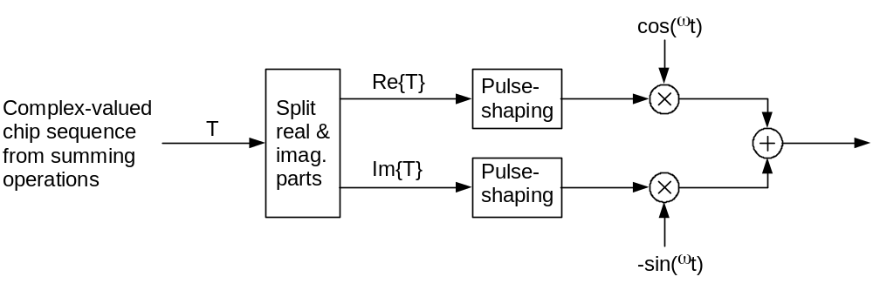
Figure 11: Downlink modulation
The pulse-shaping characteristics are described in [4].

Annex A (informative):
Generalised Hierarchical Golay Sequences

A.1 Alternative generation
The generalised hierarchical Golay sequences for the PSC described in 5.2.3.1 may be also viewed as generated (in real valued representation) by the following methods:
Method 1.
The sequence y is constructed from two constituent sequences x₁ and x₂ of length n₁ and n₂ respectively using the following formula:
- y(i) = x₂(i mod n₂) * x₁(i div n₂), i = 0 ... (n₁* n₂) - 1.
The constituent sequences x₁ and x₂ are chosen to be the following length 16 (i.e. n₁ = n₂ =16) sequences:
- x₁ is defined to be the length 16 (N⁽¹⁾=4) Golay complementary sequence obtained by the delay matrix D⁽¹⁾ = [8, 4, 1,2] and weight matrix W⁽¹⁾ = [1, -1, 1,1].
- x₂ is a generalised hierarchical sequence using the following formula, selecting s=2 and using the two Golay complementary sequences x₃ and x₄ as constituent sequences. The length of the sequence x₃ and x₄ is called n₃ respectively n₄.
- x₂(i) = x₄(i mod s + s*(i div sn₃)) * x₃((i div s) mod n₃), i = 0 ... (n₃* n₄) - 1.
- x₃ and x₄ are defined to be identical and the length 4 (N⁽³⁾= N⁽⁴⁾=2) Golay complementary sequence obtained by the delay matrix D⁽³⁾ = D⁽⁴⁾ = [1, 2] and weight matrix W⁽³⁾ = W⁽⁴⁾ = [1, 1].
The Golay complementary sequences x₁,x₃ and x₄ are defined using the following recursive relation:
a₀(k) = δ(k) and b₀(k) = δ(k);
a_{n}(k) = a_{n-1}(k) + W^{(j)}_{n}·b_{n-1}(k-D^{(j)}_{n});
b_{n}(k) = a_{n-1}(k) - W^{(j)}_{n}·b_{n-1}(k-D^{(j)}_{n});
k = 0, 1, 2, …, 2**N^{(j)} -1;
n = 1, 2, …, N^{(j)}.
The wanted Golay complementary sequence x_{j} is defined by a_{n} assuming n=N^{(j)}. The Kronecker delta function is described by δ, k,j and n are integers.
Method 2
The sequence y can be viewed as a pruned Golay complementary sequence and generated using the following parameters which apply to the generator equations for a and b above:
(a) Let j = 0, N⁽⁰⁾ = 8.
(b) [D₁⁰,D₂⁰,D₃⁰,D₄⁰,D₅⁰,D₆⁰,D₇⁰,D₈⁰] = [128, 64, 16, 32, 8, 1, 4, 2].
(c) [W₁⁰,W₂⁰,W₃⁰,W₄⁰,W₅⁰,W₆⁰,W₇⁰,W₈⁰] = [1, -1, 1, 1, 1, 1, 1, 1].
(d) For n = 4, 6, set b₄(k) = a₄(k), b₆(k) = a₆(k).

Annex B (informative):
Change history
Change history
Date | TSG # | TSG Doc. | CR | Rev | Subject/Comment | Old | New
14/01/00 | RAN_05 | RP-99589 | - |  | Approved at TSG RAN #5 and placed under Change Control | - | 3.0.0
14/01/00 | RAN_06 | RP-99682 | 005 | 1 | Harmonization of notations for downlink scrambling codes | 3.0.0 | 3.1.0
14/01/00 | RAN_06 | RP-99683 | 006 | - | Update of downlink spreading description | 3.0.0 | 3.1.0
14/01/00 | RAN_06 | RP-99682 | 007 | 1 | Update of TS 25.213 uplink parts | 3.0.0 | 3.1.0
14/01/00 | RAN_06 | RP-99683 | 008 | - | Updated modulation description | 3.0.0 | 3.1.0
14/01/00 | RAN_06 | RP-99683 | 009 | - | Restriction for spreading factor 512 allocation in the UTRA FDD Downlink | 3.0.0 | 3.1.0
14/01/00 | RAN_06 | RP-99683 | 011 | 1 | CPCH codes in power control preamble | 3.0.0 | 3.1.0
14/01/00 | RAN_06 | RP-99683 | 012 | 2 | Support of short codes for CPCH | 3.0.0 | 3.1.0
14/01/00 | RAN_06 | RP-99682 | 014 | 1 | Editorial Change | 3.0.0 | 3.1.0
14/01/00 | RAN_06 | RP-99683 | 016 | - | Channelization Code Allocation for USTS | 3.0.0 | 3.1.0
14/01/00 | RAN_06 | RP-99683 | 017 | 1 | Correction (Editorial Change) | 3.0.0 | 3.1.0
14/01/00 | RAN_06 | RP-99683 | 019 | - | Correction to code allocation for compressed mode | 3.0.0 | 3.1.0
14/01/00 | - | - | - |  | Change history was added by the editor | 3.1.0 | 3.1.1
31/03/00 | RAN_07 | RP-000063 | 020 | 1 | Consistent numbering of scrambling code groups | 3.1.1 | 3.2.0
31/03/00 | RAN_07 | RP-000063 | 021 | - | Downlink signal flow corrections | 3.1.1 | 3.2.0
31/03/00 | RAN_07 | RP-000063 | 022 | - | Uplink signal flow corrections | 3.1.1 | 3.2.0
31/03/00 | RAN_07 | RP-000063 | 023 | 1 | Number of RACH scrambling codes | 3.1.1 | 3.2.0
31/03/00 | RAN_07 | RP-000063 | 024 | 1 | Editorial changes to 25.213 | 3.1.1 | 3.2.0
31/03/00 | RAN_07 | RP-000063 | 025 | 3 | Number of PCPCH scrambling codes per cell | 3.1.1 | 3.2.0
31/03/00 | RAN_07 | RP-000063 | 027 | - | A typo correction for 5.2.2 and clarification for 5.2.3.1 of TS 25.213V3.1.1 | 3.1.1 | 3.2.0
31/03/00 | RAN_07 | RP-000063 | 028 | 2 | Channelization code allocation method for PCPCH message part | 3.1.1 | 3.2.0
31/03/00 | RAN_07 | RP-000063 | 029 | - | Clarifications to DSCH scrambling and modulation in 25.213 | 3.1.1 | 3.2.0
31/03/00 | RAN_07 | RP-000063 | 032 | - | Clean up of USTS related specifications | 3.1.1 | 3.2.0
26/06/00 | RAN_08 | RP-000267 | 033 | - | Clarifications to power control preamble sections | 3.2.0 | 3.3.0
26/06/00 | RAN_08 | RP-000267 | 034 | 2 | Numbering of the PCPCH access preamble and collision detection preamble scrambling codes | 3.2.0 | 3.3.0
26/06/00 | RAN_08 | RP-000267 | 035 | - | DPDCH/DPCCH gain factors | 3.2.0 | 3.3.0
16/12/00 | RAN_10 | RP-000539 | 037 | 1 | Proposed removal of the option of secondary scrambling code for some downlink common channels | 3.3.0 | 3.4.0

